Week 1 Fruit of the spirit
LOVE
Craft:
Get the children to stick red tissue paper onto the apple

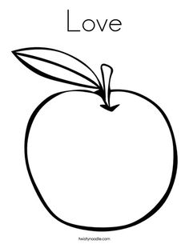
Discussion:
Talk to them about who loves them.
And how much God loves them.
Use the bubbles to encourage the children to come to the carpet area.
Song this term……
God’s love is higher than the mountains (point up)
Deeper than the sea (point down)
Wider than the biggest hill (stretch arms wide)
Is how much God loves me (cross arms over chest)
Please feel free to use the song board again this term.

